**20th September 2024**

**Woodland Improvements Pembrokeshire – Mount Woods Accessible Pathwa**ys

**Invitation to tender**

Coed Lleol is seeking qualified contractors to carry out groundworks to improve accessibility for two main public rights of ways to and within Mount Woods (Milford Haven). The work aims to enhance the usability of the woodland for the local community, ensuring that paths are safe, sustainable, and accessible to all members of the public, including those with mobility impairments. The aim is to make an amount of land made wheelchair accessible/step free.

Coed Lleol and Pembrokeshire County Council are in collaboration to support this project.

**Background and additional information**

The woodland is owned by multiple stakeholders:

* VC Gallery: local charity, leasing most of the woodland
* John Taylor; local farmer
* Keith Knight; local farmer/resident
* David Pugh; local resident

The paths requiring work are **200m** each in length (negotiable) and **2m** wide (non-negotiable).

The woodland floor is uneven and can be challenging to navigate. The ground is often muddy, especially after rain, with areas of thick, sticky mud that can make footing unstable. Patches of exposed roots and rocks protrude from the soil, creating tripping hazards and making it difficult for those with mobility issues to walk safely. In some places, the ground is slippery due to wet leaves and moss, while other areas might be boggy, with water pooling in low spots.

These paths are owned by a local farmer named John Taylor and serve as public rights of way. They lead into a section of the woodland leased by The VC Gallery in Haverfordwest. Recently, The VC Gallery charity carried out tree work to create a safer woodland environment. This included the felling of large ash trees affected by ash dieback disease, which posed a serious threat to public access.

Mount Woods has the potential to offer a variety of benefits for residents. However, there is a need for work to enhance safety and improve accessibility. Previous work has been done, but due to lack of maintenance the two main paths in question have become unusable, leaving some parts unusable (e.g. steps that have rotted away).

No SSSI’S reported.

No extraction of timber required.

**Considerations that need to be addressed in the tender:**

The scope of work includes but is not limited to the following:

* **Clearing and levelling**: Removal of obstructions, debris, and overgrowth from existing paths.
* **Surface preparation**: Grading and compacting of soil to provide a stable foundation for the new paths; 50mm thick.
* **Path surfacing**: Laying a suitable path surface (e.g., gravel, compacted earth, or permeable paving) that is durable, non-slip, wheelchair and easily maintained for future use. Stone aggregate: 20mm to dust.
* **Drainage**: Installation of adequate drainage systems to prevent waterlogging and erosion.
* **Signage and wayfinding**: Installation of signs to guide users along the paths, including accessibility information.
* **Border definition**: Installation of edging to define path borders and prevent encroachment by vegetation.
* **Stock proof fencing -** to be discussed with landowner.
* **Environmental considerations**: Minimizing the impact on local wildlife and vegetation during the works. A need for work and materials sympathetic to the woodland environment.
* Street works notification/license will be facilitated by Small Woods.
* Road/street closures will be facilitated by Small Woods

**Timeframe**

Deadline for submissions: **12:00pm 9th October 2024**

Work completed and invoiced by: **5th December 2024**

**Location**

Mount woods, Milford Haven, Pembrokeshire

**Budget guidelines**

The total budget allocated is £25,000, inclusive of VAT.

No funds will be available beyond the end of Dec 2024.

**The Client is:**

Small Woods – Coed Lleol   
<https://www.smallwoods.org.uk/>

Lead contact: Calum Stark

Woodland Management Project Officer, Pembrokeshire

**Terms of the invitation to tender**

Examples of previous work encouraged.

A site visit will be organized to allow potential contractors to inspect the paths and assess the work required.

All communication through lead contact.

**Contractor Requirements:**

**Qualifications and Experience**

* Proven experience in groundworks, particularly in natural or woodland environments.
* Demonstrated ability to work within sensitive environmental settings.
* Experience in constructing accessible pathways.

**Health and Safety**

* The project must be compliant with Construction, Design and Management (CDM) regulations, the successful contractor will be expected to undertake CDM roles of principal contractor and principal designer.
* Ability to produce detailed Health and Safety Plan must be provided, including risk assessments specific to the project.
* All personnel must be appropriately trained and equipped.

**Environmental Protection**

* Compliance with environmental regulations.
* A plan for minimizing disruption to local wildlife and vegetation.
* Waste management plan, including disposal of materials in an environmentally responsible manner.

**Insurance**

* Public liability insurance
* Employer’s liability insurance

**Tender Submission Requirements**

Interested contractors are required to submit the following:

* **Company profile**: Including relevant experience and case studies.
* **Method statement**: Detailed plan on how the contractor intends to carry out the works.
* **Health and Safety Plan**: Including outlining risk assessments and safety procedures.
* **Environmental Management Plan**: Detailing how environmental impact will be minimized.
* **Cost proposal**: Comprehensive breakdown of costs, including materials, labour, equipment, and contingencies.
* **References**: At least two references from previous clients for similar work.

Copies of relevant insurances should be provided at point of submission, as well as any other relevant qualifications.

Contractor is to provide documentation to the public rights of way officer.

**Map of proposed works**

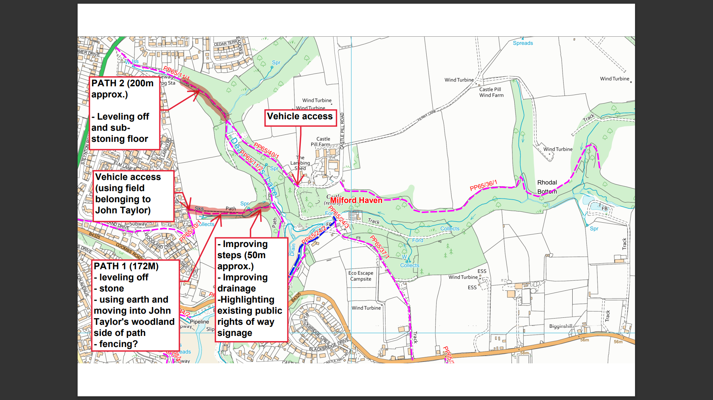

**Template for Expression of Interest**

**Additional documents will be accepted, and sending examples of previous work is encouraged.**

|  |  |
| --- | --- |
| **Organisation Details** | |
| Name of interested organisation |  |
| Name of main contact and contact details (email, telephone, postal address) |  |
| **Specification of Interest** | |
| Why are you interested in this tender? |  |
| **Experience** | |
| Please outline your experience in:   * Managing, co-ordinating and delivering woodland improvements * Knowledge of woodlands and working in a sympathetic way with the local environment * Addressing and progressing key milestones. * Completing work to a deadline. |  |
| Any other information you would like to supply. |  |
| **Outline costs** |  |
| Please give as accurate a budget as possible, to include labour and materials. This budget should not exceed £25K |  |
| **Authenticity** |  |
| I confirm that all the information above is true to the best of my knowledge. |  |

**Background**

Since 2010, Coed Lleol-Small Woods’ focus has been on supporting communities, especially those high on the Welsh Index of Multiple Deprivation, to engage positively with their natural environments to improve health and wellbeing through the provision of woodland and nature-based wellbeing activities.

The work, (currently funded by Healthy & Active, Enabling Natural Resources & Wellbeing and Natural Resources Wales) has grown significantly over the last 12 years. Within the 18 counties across Wales, Coed Lleol-Small Woods now works with approximately 120 activity leaders and over 1500 participants per year.

We work collaboratively with local providers to understand and meet local needs. In partnership with others, Coed Lleol-Small Woods provide: training and skills development (including a Wellbeing in Nature Qualification); creates the design of referral pathways for health services; resources; and expertise to make high-quality green social prescribing happen, with and for the local community.

Research and evaluation are key to providing evidence of our impact. Coed Lleol-Small Woods is proud to report that over the last three years, 70% of participants, completing baseline and progress questionnaires, showed improved wellbeing as measured by the Warwick–Edinburgh Mental Wellbeing Scale. 95% of participants report feeling happier because of taking part.

Alongside the woodland wellbeing activities, Coed Lleol-Small Woods have developed other ways to offer support and improve the social prescribing landscape in Wales:

* **Remote Services -** online resources, including [YouTube videos](https://www.youtube.com/c/CoedLleolSmallWoods), online programmes, and Nature Chat, a telephone service offering one-to-one support to individuals suffering from social isolation.
* **Woodland Hubs -** three Woodland Hub sites are being developed and a further ten sites are being improved across Wales to make them more accessible, three more weather-proof and more usable at all times of year and by people of all abilities.
* **Outdoor Health Networks -** Coed Lleol-Small Woods work with organisations providing health and wellbeing services in other outdoor settings, including horticulture, water sports and interaction with animals.

**Coed Lleol-Small Woods’ Vision**

In the future the aim is to...

* Support the delivery of programmes in ***every county*** of Wales with every health board;
* **Expand our outdoor health networks**, to reach more people across Wales;
* **Support the network of outdoor wellbeing leaders** to meet minimum standards;
* **Provide quality assurance** and improve communication with health services;
* Ensure there are **safe, dry and accessible outdoor spaces** across Wales;
* **Provide a national map** of resilient 'wellbeing woodlands’;
* **Monitor and promote outcomes** to provide an evidence base.